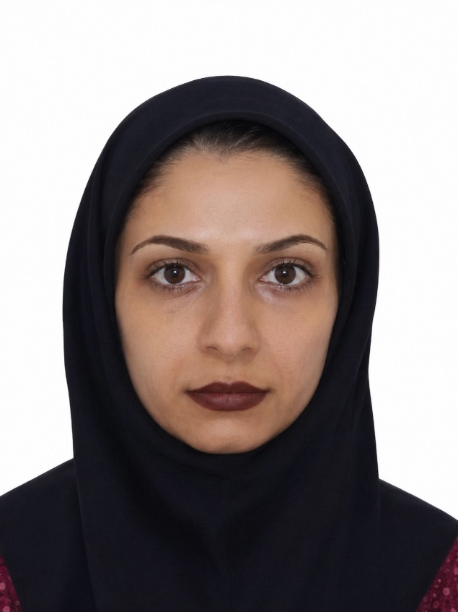
Zohre Shabbooie
ORCID: 0000-0002-8585-2266
Google Scholar: Zohre Shabbooie
Email: z.shabbooie@gmail.com
Phone: +98-9176395531
Location: Shiraz, Iran

Professional Summary
Faculty member in medical journalism with a strong background in scientific writing, medical journal editing, clinical research dissemination, and academic publishing. Experienced in translating complex clinical cases into peer-reviewed publications and contributing to interdisciplinary medical research. Recognized as a National Outstanding Employee by the Iranian Ministry of Cooperatives, Labour and Social Welfare in 2025.

Academic Position
Faculty Member, Department of Medical Journalism
Shiraz University of Medical Sciences, Shiraz, Iran
[2024 – Present]
- Conduct research in medical journalism and scientific communication
- Publish peer-reviewed articles in international journals
- Mentor students in academic writing and publication processes
- Collaborate with clinical teams to document and publish novel medical cases

Clinical & Professional Experience
Head Nurse
Private Hospital, Shiraz, Iran
[4 Years]
- Supervised nursing staff and coordinated patient care services
- Managed clinical documentation and interdisciplinary communication
- Contributed to quality improvement and patient safety initiatives
Language Editor
Galen Medical Journal, Fasa University of Medical Sciences, Iran
- Edited scientific manuscripts for language accuracy and academic quality
- Assisted authors in improving clarity and publication readiness
Executive Team Member – Summer School Program
Fasa University of Medical Sciences, Iran
- Participated in organizing and coordinating academic summer school programs
- Assisted in educational planning and event management activities

Honors & Awards
- National Outstanding Employee Award, Ministry of Cooperatives, Labour and Social Welfare, Iran (2025)

Education
M.Sc. in Medical Journalism
Shiraz University of Medical Sciences, Shiraz, Iran
Graduated: 2019
B.Sc. in Anesthesiology
Fasa University of Medical Sciences, Fasa, Iran
Graduated: 2012

Publications
- Liaghat O, Shabbooie Z. Ectopic banking and implantation of an amputated hand. Indian Journal of Orthopaedics. 2020;54(5):731–737.
- Liaghat O, Shabbooie Z. Heel reconstruction using a combination of free sensate medial plantar flap and skin graft: A case series. JPRAS Open. 2025;44:251–258.
- Shabbooie Z, Shokrpour N. Readability of English Articles Published in Iranian Medical Journals and Their Comparison with Articles Published in English and American Medical Journals in 2018. Journal of Health Sciences & Surveillance System. 2021;9(4):253–256.
- Tavallaei A, Shabbooie Z, Sharafkhaneh A. Anesthesiologist awareness of risk of sleep apnea and postoperative complications. Scandinavian Journal of Sleep Medicine. 2021;1(1).

Research Interests
- Medical Journalism
- General Health
- Medical and Nursing Services
- Scientific Writing and Editing
- Clinical Case Reporting
- Health Communication

Skills
- Academic Writing & Editing
- Scientific Publishing
- Research Methodology
- Clinical Documentation
- Medical Journalism and Health Communication
- Languages: Persian (Native), English (Fluent)

Professional Activities
- Academic research and publication in peer-reviewed journals
- Member of editorial boards in international medical journals
- Reviewer of specialized medical manuscripts in international medical journals
- Collaboration with multidisciplinary medical teams
- Scientific manuscript reviewing and editing
- Research dissemination and medical content development

